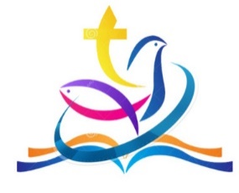

THE SIX CHURCHES OF CAM VALE
SERVICES FOR THE MONTH OF NOVEMBER 2024
Sunday 3rd November:
9.30 am All age service Queen Camel
10.00 am Holy Communion Corton Denham
3.00 pm All Souls’ Service Queen Camel
3.00 pm Tea @ Three West Camel

Sunday 10th November
10.45 am Remembrance Service Corton Denham
10.50 am Remembrance Service West Camel
10.50 am Remembrance Service Queen Camel
10.50 am Remembrance Service Weston Bampfylde
10.50 am Remembrance Service Sparkford
10.50 am Remembrance Service Sutton Montis

Sunday 17th November
9:30 am CW Holy Communion Queen Camel
11.00 am BCP Holy Communion Sparkford
3.00 pm Methodists’ service West Camel

Sunday 24th November
10:00 am Together @ 10 Sutton Montis
3:00 pm Methodists’ service West Camel

