Weston Bampfylde and Little Weston
Newsletter June 2023
What a month May was, with the Coronation celebrations and then the floods. I say more about this in the Parish Letter, which I wrote this month. The Cam Vale Parish Office is closed at the moment because of the flooding at The Old School and Julia is working from home. Her contact details are under contacts below.
Sally Strelley was elected churchwarden at the Annual Parochial Church Meeting, and her contact details are below.
Contact for the Village Hall
Booking secretary and Treasurer
Rob Malton, email; r.malton@btinternet.com. Tel, 01963 440663
Newsletter contact
Alan Hoskins, email: alanhoski@gmail.com Tel: 01963 440026
Contacts for Holy Cross Church
Parish Office; Julia Skelhorn, email: admincamvale@gmail.com
Tel: 01963 220586
Churchwardens;
Alan Hoskins, email: alanhoski@gmail.com Tel: 01963 440026
Sally Strelley, email: sallystrelley82@gmail.com
Tel: 01963 440870

Bell ringing and prosecco after the Coronation
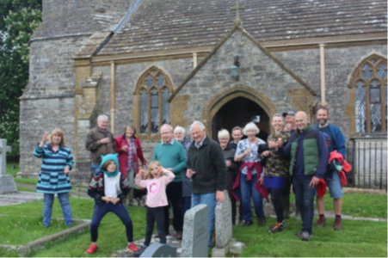
Parish Letter
What a difference a day makes
I am writing this at the end of a very contrasting, and somehow strange week. We started with the Coronation celebrations, with that superb service in Westminster Abbey for the Coronation of Charles III. Most of us in our villages watched the service on television. I felt that our King seemed quite nervous and only relaxed once the crowning was finished, but I thought it was a very intimate and thoughtful and special service that reflected King Charles concerns and priorities.
Once the television broadcast had finished with the appearance on the balcony at Buckingham Palace, and the fly past, a few of us gathered at Weston Bampfylde to ring the church bells and to drink a toast to our newly crowned King. This seemed to start the community events which could be described as one prosecco after another!!
The Sunday, as in all our villages, was the day of community celebrations. Our little village had a lunch, treasure hunt, and tea centred around the village hall. Around fifty Weston Bampfylde and Little Weston residents and their families came during the day to enjoy wonderful food and a really good day. The spread of food in the village hall was a sight to behold and quite delicious and all of it was brought by the people of the community. I am sure the celebrations in all the other villages in Cam Vale were just as good.
Then on the Monday there was the volunteering day, and I noticed when passing that there were many visitors to the open day at the Old School in Queen Camel.
Then came Tuesday, and what a contrast, with the deluge!! Most of our villages had properties flooded, including my brother’s at Weston Mill and the Old School, but once again people from the community came together to help.

I am sure that everybody who had water in their homes have had many offers of help from friends and neighbours. Frank and Shirley certainly have.
Reflecting on all of this emphasises just how fortunate we are in our villages to have such active and caring communities. When in the space of less than a week we can celebrate together, laugh together and support each other in times of difficulty, it shows how valuable our neighbours are. We must value and nurture these communities and villages. Many of the people affected by the floods will need our support and love in the weeks ahead before things are back to some sort of normality.
Let us pray that all those in our villages are kept in our thoughts and prayers, and that our village communities can continue to be places of fun and laughter as well as support.
Alan Hoskins.
The Open Pathway
A message from Christy and Daniel Francis
A big thank you to all who helped clear the mud after the recent flood.
We are having to close the Centre completely until 13th June for electrical and waterboard work to be carried out and have limited availability until 1st July. Classes still taking place in June are:
Wellbeing Day 15th June, Yoga classes from 16th June, Aqua Yoga classes from 19th June and Natural Energy Therapy appointments.
We look forward to being fully open in July and to Christy finishing her Sarum College Reader Training.
With all good wishes and our prayers for all those affected by the flooding.
Christy and Daniel Francis

