**Special service for Palm Sunday (****Sunday April 2nd)**

Beginning with a procession with our local donkeys

from Weston Bampfylde Village Hall at 9.45a.m.

followed by service in church at 10.00a.m.

and refreshments.

ALL WELCOME

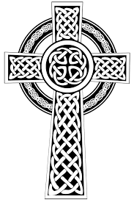**Good Friday Pilgrimage**

**Friday April 7th 2023**

Beginning at St Andrew’s Corton Denham at 9.30a.m.

then on to Holy Trinity, Sutton Montis for 11.00a.m.

Holy Cross, Weston Bampfylde for 12.00a.m.

(Where we stop to eat our picnic lunch)

St Mary Magdalene, Sparkford for 1.30p.m.

St Barnabas, Queen Camel for 2.30p.m.

and finishing at All Saints, West Camel at 3.30.p.m.

Please do join us for all of part of the Pilgrimage.

Children, dogs and animals and all who enjoy a walk

are especially welcome to join us.

If you are not wishing to walk,

please feel free to join us for the times of reflection in our local churches.

Our reflections this year are based on excerpts from

‘The Journey’ by The Rt Revd John Pritchard

(former Bishop of Oxford).

 At each stop on our pilgrimage there will be:

Time for prayer

Time to share in the story

through word, music and image.

Time for reflection and listening

and for conversation along the way.

**Easter Day**

**(Sunday April 9th)**

**An informal Easter Celebration at 6a.m.**

**on Corton Beacon.**

(weather permitting)

All welcome, especially walkers and dogs

to come and enjoy a sing, a prayer and a sunrise.

**Happy Easter, everyone!**