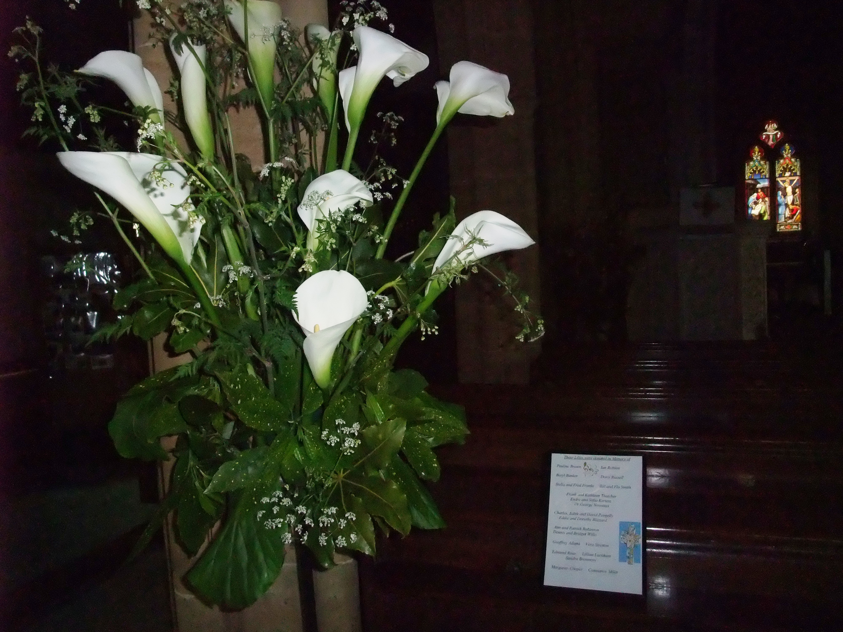
Lilies to remember our dearly departed ones

