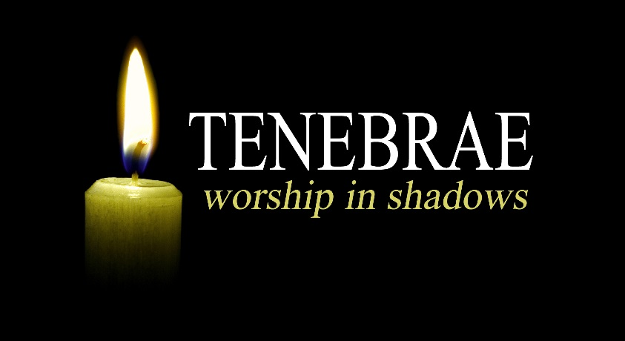Maundy Thursday

April 13th

at 7p.m.

All Saints, West Camel.

**Tenebrae comes from the Latin word meaning darkness. The Tenebrae is an ancient Christian service that leads us from Maundy Thursday into Good Friday.**

**It is a quiet service of music, reading and reflection in which we journey with Jesus through the events of Holy Week. During the service the light diminishes as candles are extinguished. This increasing darkness symbolizes the approaching darkness of Jesus death. There is a simple sharing of bread and wine as we remember Jesus final supper with his friends.**

**At the end of the service we leave in silence to ponder the events of Good Friday and to await the coming of the light with Jesus resurrection on Easter day.**